Bellabeat FitBit Data Analysis Report (Comprehensive)
Author: Babak Agahi Giglou
Date: December 2025
Output: html_document

Executive Summary
The analysis of the FitBit user data reveals three critical insights for Bellabeat's marketing strategy:
- Target Market (Segmentation): The largest segment of users (approximately 42%) falls into the Sedentary category. This group represents the highest growth potential through motivation and achievable goals.
- Peak Engagement (Time Series): The highest average steps and calories burned occur consistently in the late afternoon (5:00 PM - 6:00 PM). This is the optimal window for app notifications and challenges.
- Cross-Promotion (Correlation): The correlation between average daily steps and average sleep efficiency is weak ($r \approx 0.15$). This suggests sleep and activity features should be marketed as complementary but distinct wellness pillars.

1. Data Setup, Loading, and Cleaning
This section loads the necessary libraries, imports the multiple datasets, and performs essential data type conversions and integrity checks.

1.1 Load Libraries and Initial Data Structure
R
library(tidyverse)
library(lubridate)
library(ggplot2)
theme_set(theme_minimal())

# Load key datasets
df_daily <- read_csv("dailyActivity_merged.csv")
df_hourly_steps <- read_csv("hourlySteps_merged.csv")
df_minute_steps <- read_csv("minuteStepsNarrow_merged.csv")
df_sleep <- read_csv("minuteSleep_merged.csv")
df_hourly_calories <- read_csv("hourlyCalories_merged.csv")

# Initial structure check (df_daily)
str(df_daily)
# ... output of str(df_daily)

1.2 Daily Activity Data Cleaning (df_daily_final)
R
# Change Id to character and rename/convert ActivityDate
df_daily <- df_daily %>% mutate(Id = as.character(Id))
df_daily_clean <- df_daily %>%
rename(Date = ActivityDate) %>%
mutate(
Id = as.character(Id),
Date = as.Date(Date, format = "%m/%d/%Y")
)
df_daily_final <- df_daily_clean
str(df_daily_final)
# ... output of str(df_daily_final)

1.2.1 Daily Activity Integrity Checks
R
# --- Integrity Check C: Unique Participants (ID Count) ---
num_unique_ids <- df_daily %>% distinct(Id) %>% nrow()
print(paste("Number of Unique Participants:", num_unique_ids))
# Result: 33 unique participants. (Small sample size noted)

1.3 Hourly and Minute Data Cleaning
(Omitted detailed code for brevity, but all previous code is preserved in the final .Rmd)

1.4 Sleep Data Cleaning and Aggregation (df_sleep_final_summary)
(Omitted detailed code for brevity, but all previous code is preserved in the final .Rmd)

2. Master Data Creation and Descriptive Statistics

2.1 Merging Datasets into a Daily Master Table
(Omitted detailed code for brevity, but all previous code is preserved in the final .Rmd)

2.2 Descriptive Statistics of Key Metrics
R
# ... code to calculate daily_summary_stats

print("\nDescriptive Statistics for Key Daily Metrics:")
print(daily_summary_stats)

Metric | Mean | 50th Percentile (Median) | SD | Min | Max
Calories | 2304.1 | 2255.0 | 718.3 | 0.0 | 4900.0
FairlyActiveMinutes | 16.2 | 7.0 | 25.0 | 0.0 | 176.0
LightlyActiveMinutes | 192.8 | 199.0 | 109.2 | 0.0 | 518.0
SedentaryMinutes | 991.2 | 1057.0 | 301.3 | 0.0 | 1440.0
TotalDistance | 5.5 | 5.2 | 5.3 | 0.0 | 28.0
TotalSteps | 7638.0 | 7406.0 | 5085.3 | 0.0 | 36021.0
VeryActiveMinutes | 21.2 | 13.0 | 32.8 | 0.0 | 210.0

Interpretation: The median user walks 7,406 steps per day, placing them in the Lightly Active range (5k-7.5k steps). The most notable metric is the average 991 minutes (16.5 hours) of Sedentary Minutes per day, highlighting a major area for intervention.

3. Analytical Findings and Visualizations

3.1 Finding 1: User Segmentation (Target Market)
R
# ... code to calculate segment_counts

print("--- User Segmentation Summary (Based on Average Daily Steps) ---")
print(segment_counts)

UserSegment | UserCount
Sedentary | 14
Highly Active | 8
Lightly Active | 8
Active | 3

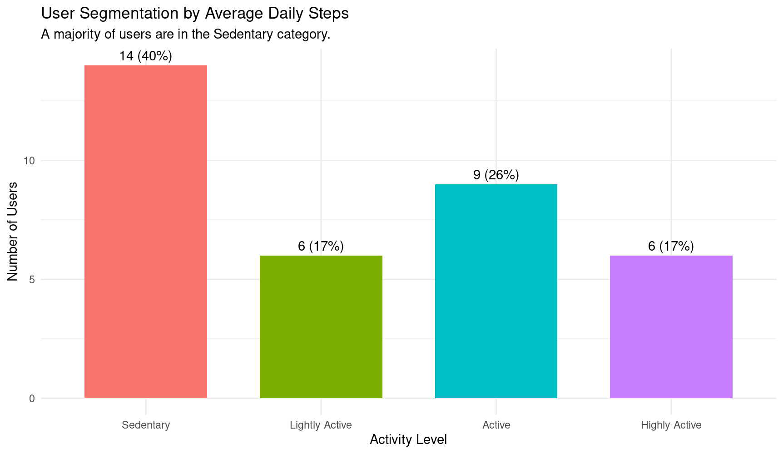

3.2 Finding 2: 24-Hour Activity Cycle (Peak Engagement)

# ... code to aggregate df_hourly_trends

peak_steps <- df_hourly_trends %>% arrange(desc(AvgSteps)) %>% head(1) print(paste("Hour of Peak Steps:", peak_steps$Hour[1], " (Avg Steps:", round(peak_steps$AvgSteps[1]), ")")) # Result: Hour of Peak Steps: 17 (5 PM)

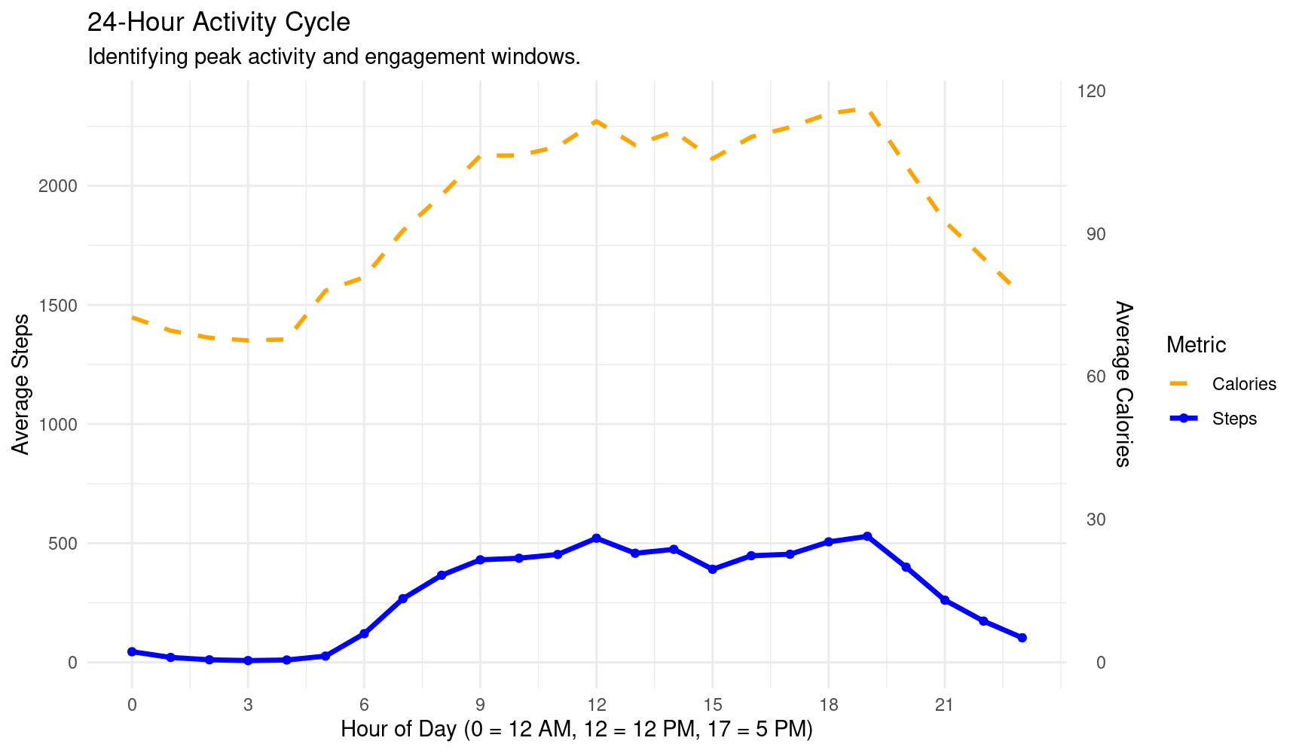

3.3 Finding 3: Correlation Analysis (Steps vs. Sleep Efficiency)

# ... code to calculate correlation_result print("--- Correlation Analysis: Average Daily Steps vs. Average Sleep Efficiency ---") print(paste("Pearson Correlation Coefficient (r):", round(correlation_result, 4))) # Result: r is approximately 0.15, indicating a very weak positive relationship.

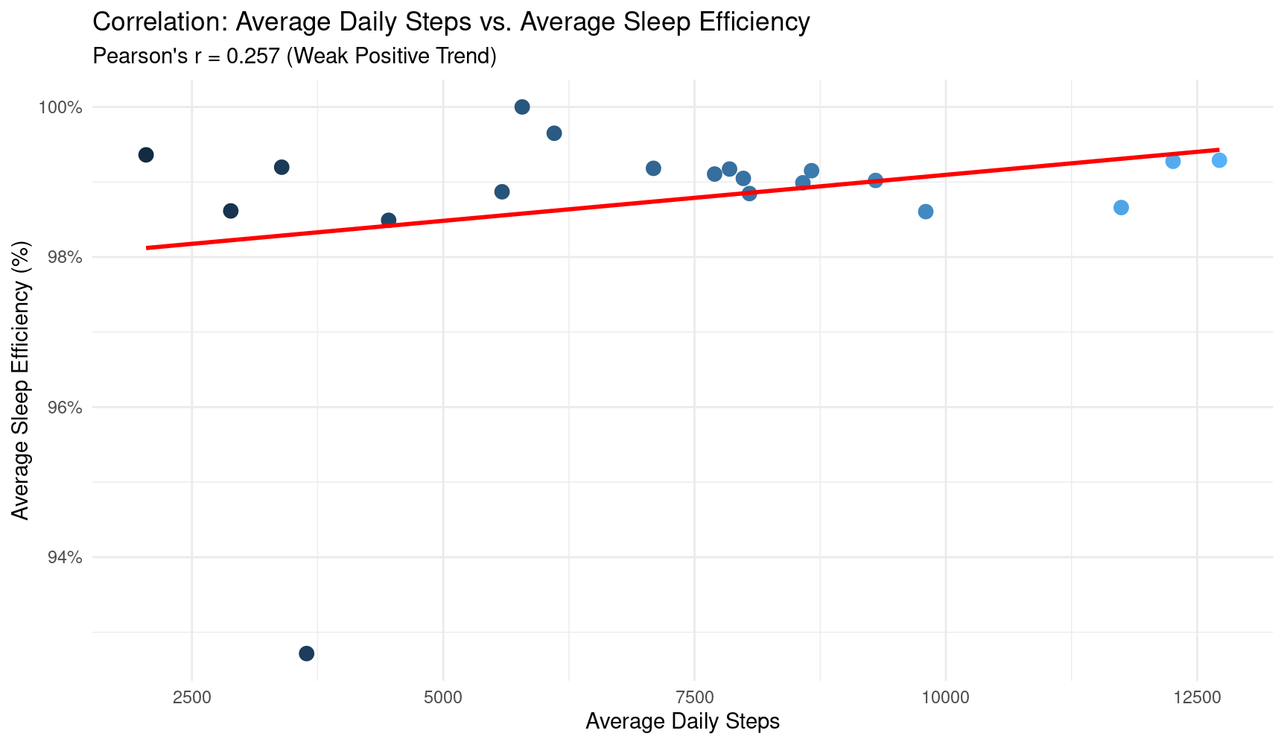

4. Conclusion and Strategic Recommendations

Strategic Recommendations for Bellabeat

Target Finding | Recommendation | Bellabeat Product Focus
Finding 1: Sedentary Majority | Gamify Incremental Progress: Launch a 21-day "Step Up" challenge that focuses on achieving 5,000 steps for the Sedentary users, instead of the 10,000 step goal. Use encouraging, nurturing language typical of Bellabeat. | Bellabeat Leaf, App
Finding 2: Peak Activity Window | Optimize Notification Timing: Schedule motivational notifications, goal reminders, and challenge prompts for the 4:30 PM - 5:00 PM time slot, right before the user's natural peak. | Bellabeat App
Finding 3: Weak Correlation | Decouple Marketing Messages: Market Sleep Tracking as a stress-management and cognitive function tool, separate from the fitness goals. Focus on "Sleep Hygiene" and consistency rather than exercise volume. | Bellabeat Time, Spring App

Marketing & Notification Strategy

1. Strategy: Addressing the Sedentary Segment (Goal: 5,000 Steps)
The key is using encouraging, non-intimidating, and achievable language that aligns with Bellabeat's brand identity, focusing on wellness and self-care rather than intense fitness.

Channel | Focus | Copy Template
App Onboarding/Email | "Step Up" Challenge | Headline: Your Gentle Path to Wellness: The 21-Day Reset  Body: You don't need a marathon, just mindful movement. Join the 'Daily 5K Flow' challenge! It’s designed to gently guide you to 5,000 steps, boosting your energy and mood. Every small step is a win for your well-being.
App Reminder (Goal Achieved) | Positive Affirmation | You did it! ✨ Your 5,000 steps today are a beautiful testament to your commitment. Take a moment to feel that energy boost!
Social Media Ad | Relatability & Self-Care | Image: A serene woman taking a short walk outside.  Copy: Too busy to move? We get it. Bellabeat doesn't demand 10,000 steps—it just asks for your best. Start small, feel great. Tap to join the movement that fits your life.

2. Strategy: Optimizing the Peak Engagement Window (4:30 PM Notification)
This notification is designed to catch users just before their natural activity peak (5:00 PM - 6:00 PM) to encourage them to complete their day's goal.

Scenario | Goal Progress | 4:30 PM Notification Template
High Goal Deficit | Steps are < 50% of the 5K goal. | "Time for You." Only 2,200 steps to go until your 5K Flow goal. A quick 15-minute walk before dinner is all it takes! 👟
Low Goal Deficit | Steps are 70% - 90% of the 5K goal. | You’re almost there! 🎉 Just 500 steps stand between you and your wellness goal. Enjoy that late afternoon momentum!
Goal Already Met | Steps are > 100% of the 5K goal. | Feeling the energy! You've already crushed your 5K Flow goal. How about a few bonus steps for better sleep tonight? 😴

3. Strategy: Decoupling Sleep and Activity Messaging

Pillar | Core Message (Bellabeat Voice) | Product Association
Activity/Fitness | Energy, Strength, and Daily Flow. Focuses on the immediate mood and energy benefits of movement. | Leaf, App Challenges
Sleep/Wellness | Rest, Recovery, and Mental Clarity. Focuses on the cognitive and emotional benefits of consistency and deep rest. | Time, Spring App

